TC-CSC-006
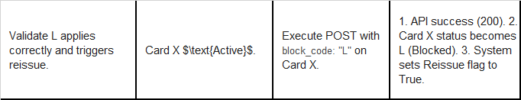
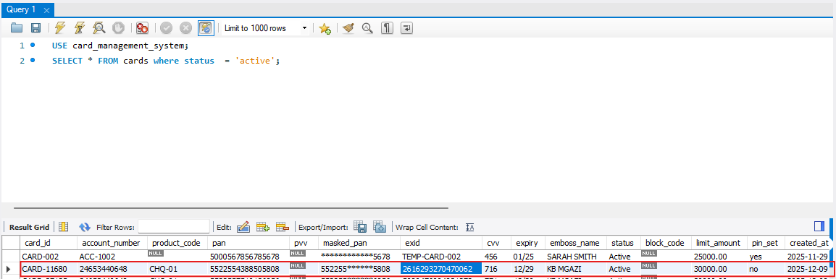
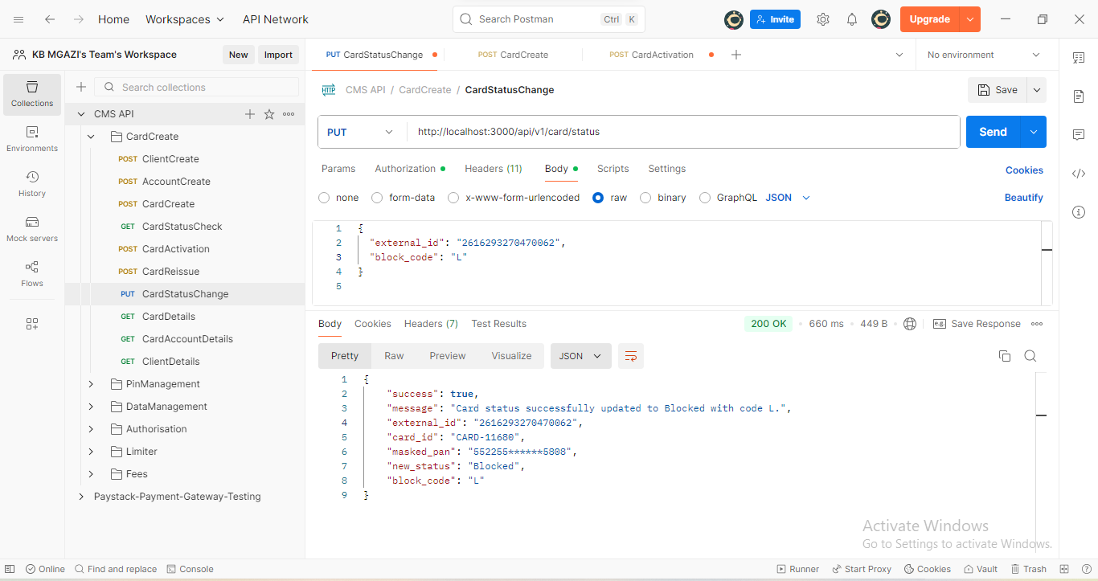
Request:
{
"external_id": "2616293270470062",
"block_code": "L"
}

Response:
{
"success": true,
"message": "Card status successfully updated to Blocked with code L.",
"external_id": "2616293270470062",
"card_id": "CARD-11680",
"masked_pan": "552255******5808",
"new_status": "Blocked",
"block_code": "L"
}

